**Assignment 6.1**

**Problem Statement:**

**Problem statement 1:**

Find out how many people has chosen their destination as MIA and MCO.

**Problem statement 2:**

Find out the number of people undertaken the trips from the places MIA and HOU.

**Problem statement 3:**

Find out how many people has chosen airline mode of travel for the places LAS and LAX.

**Dataset:**

The data set is downloaded from the following link

<https://github.com/prateekATacadgild/DatasetsForCognizant/blob/master/TravelData.txt>

**Program:**

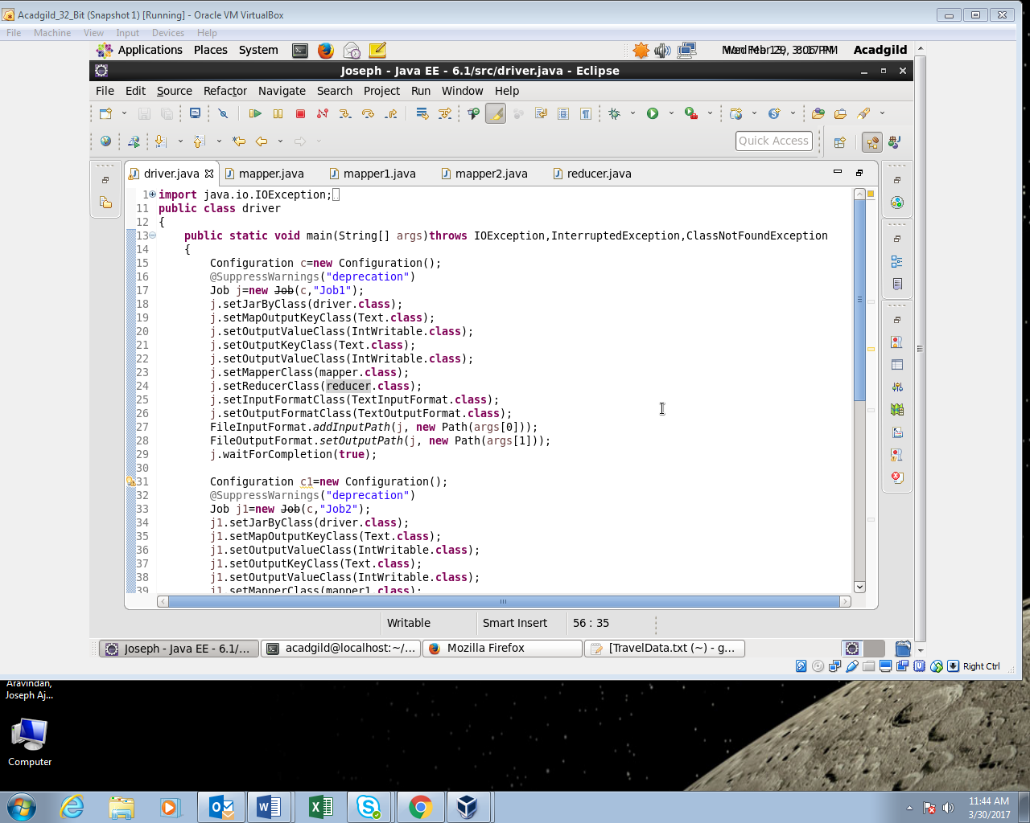

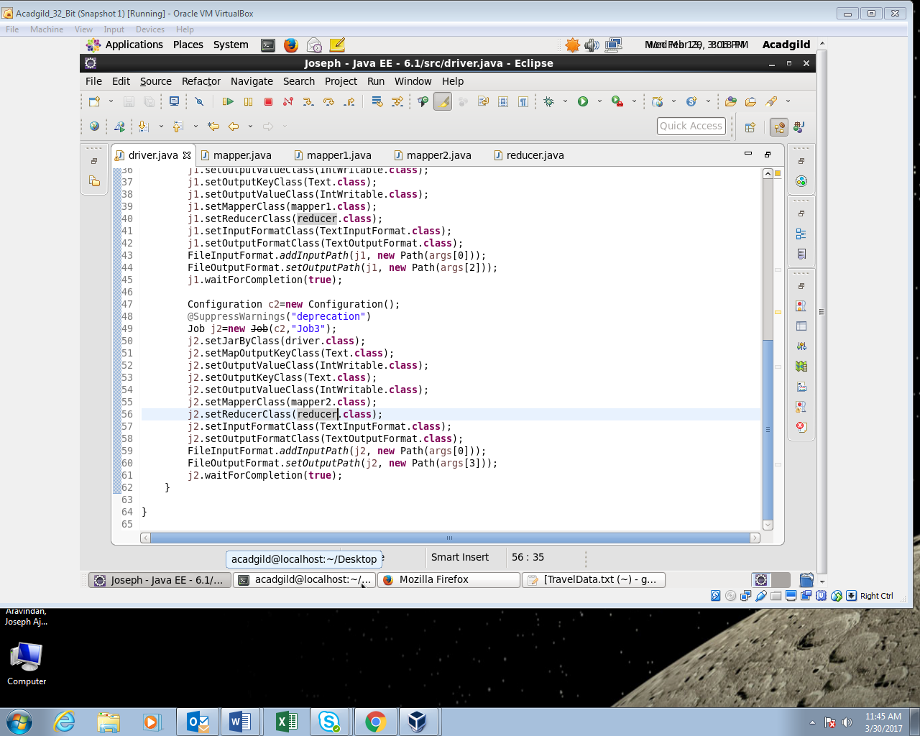

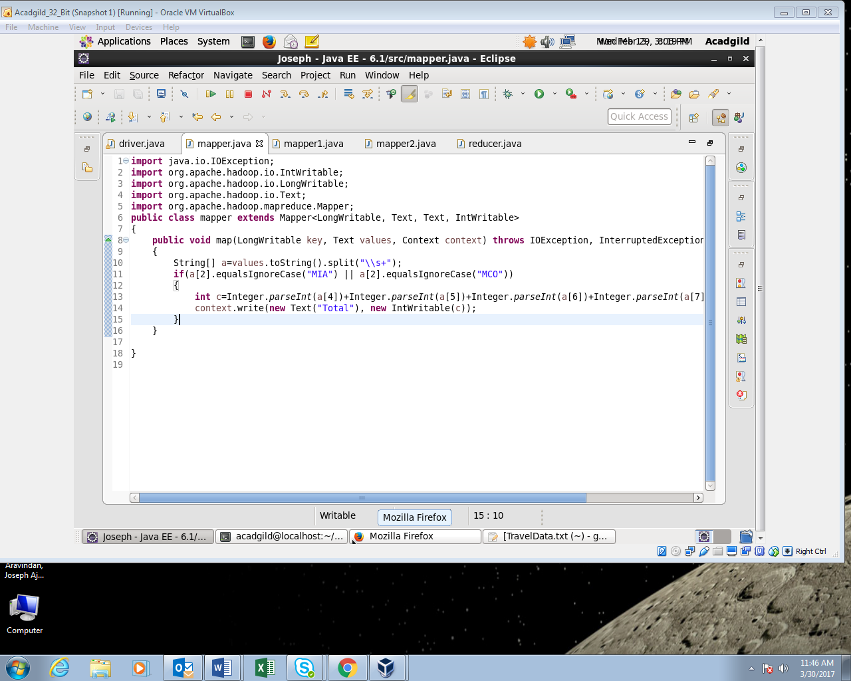

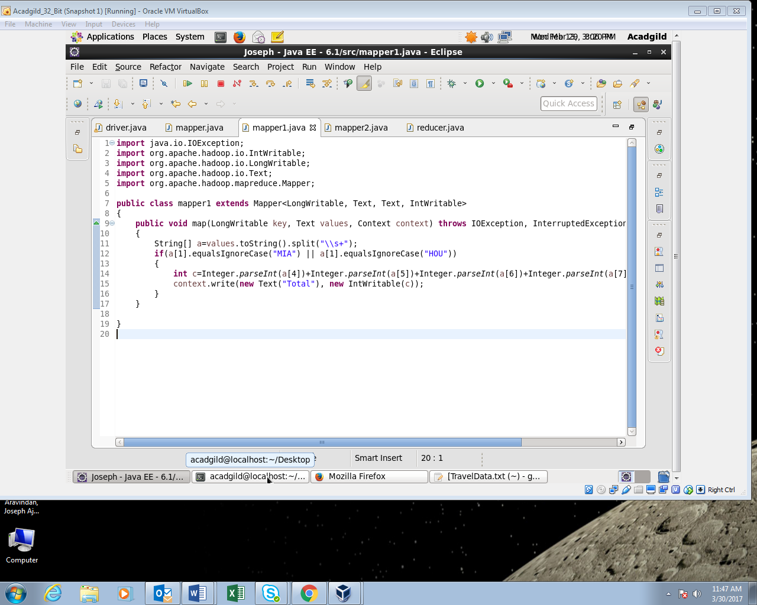

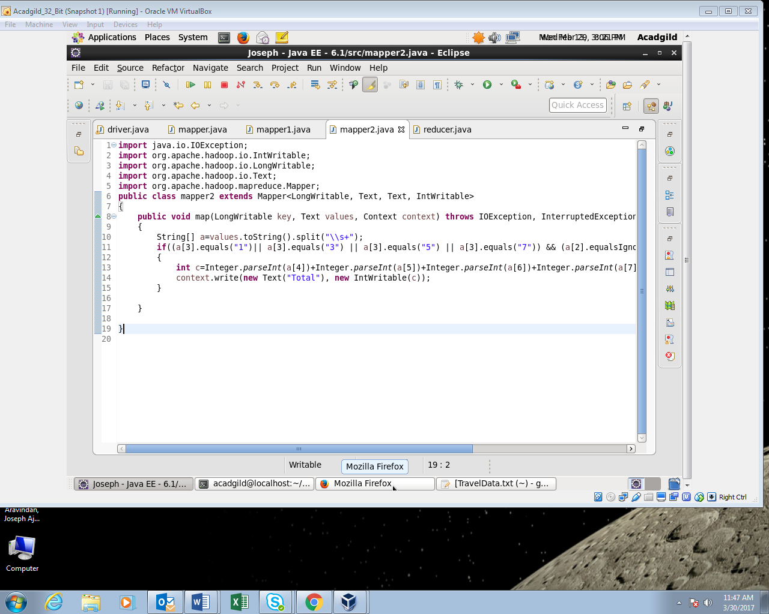

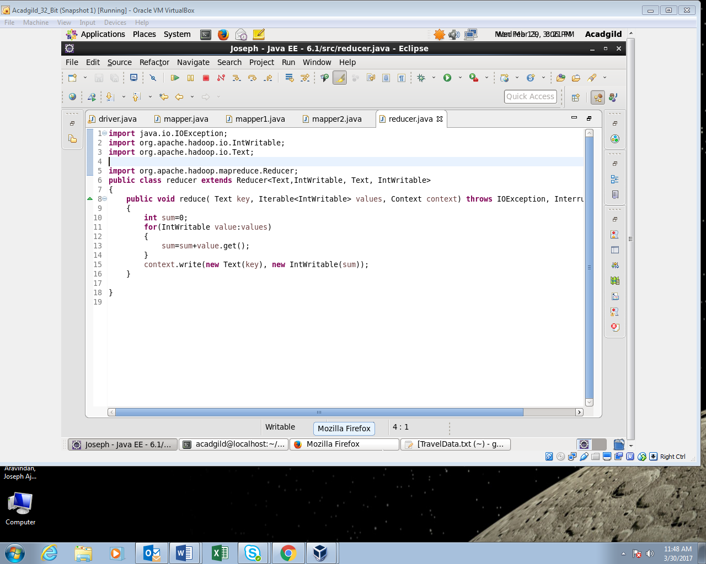

**Output:**

